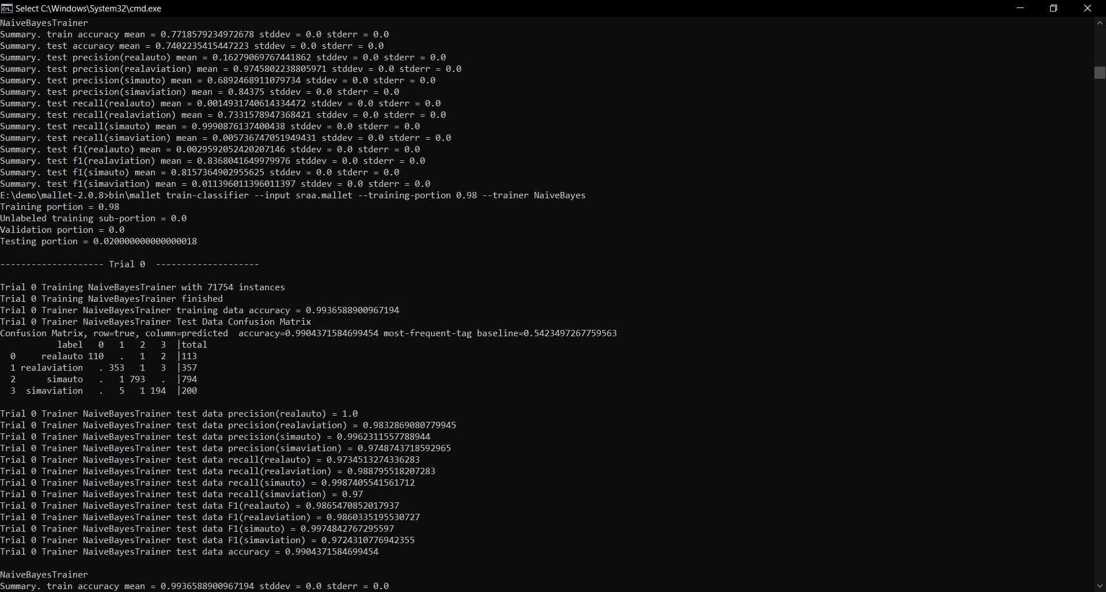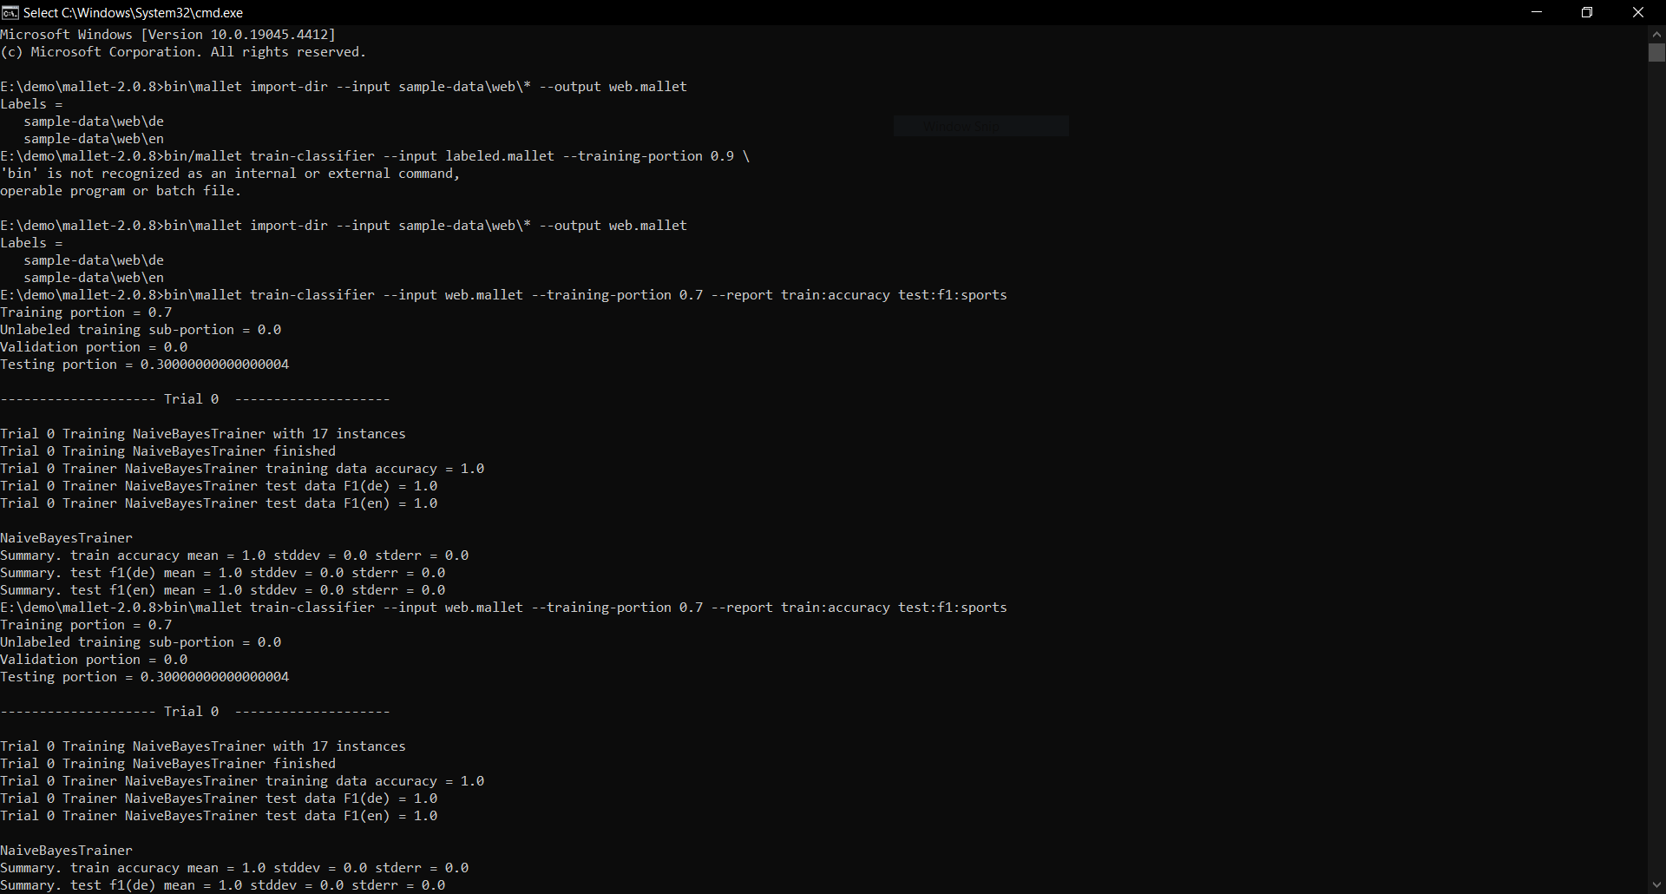

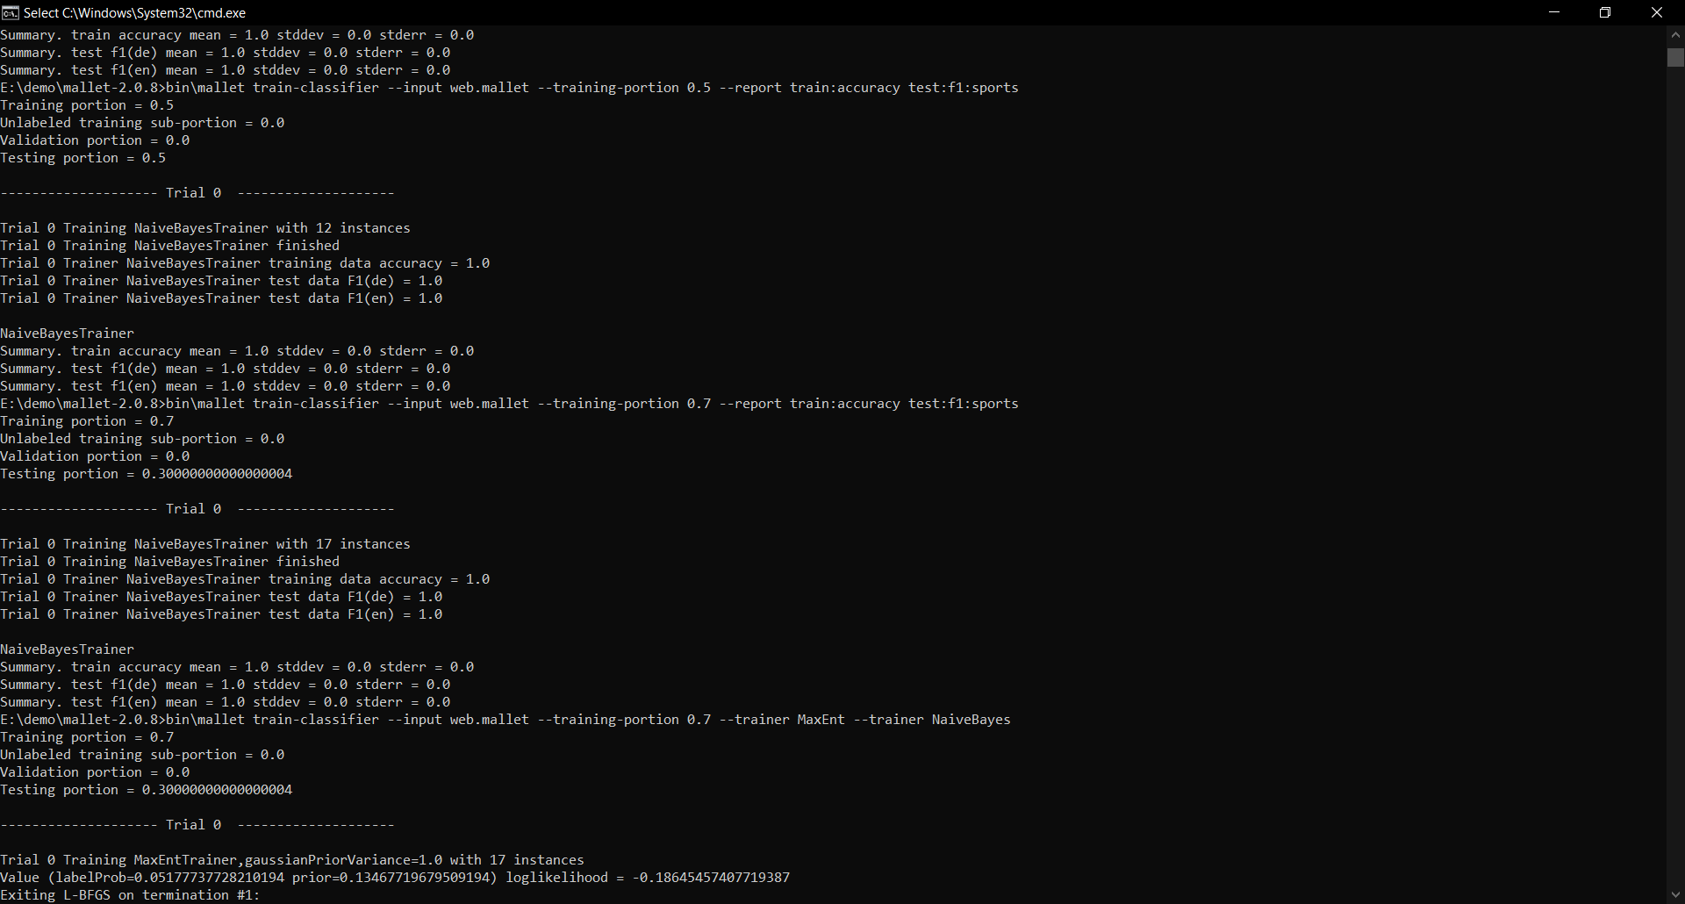

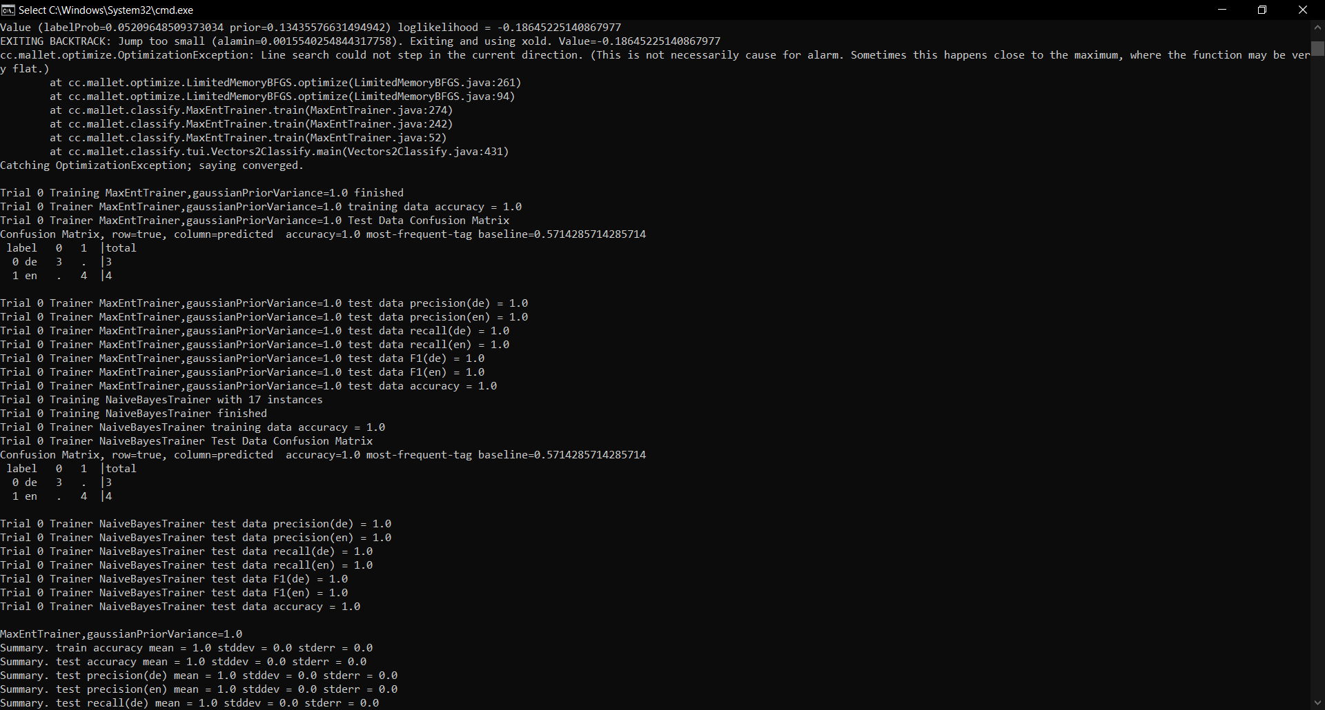

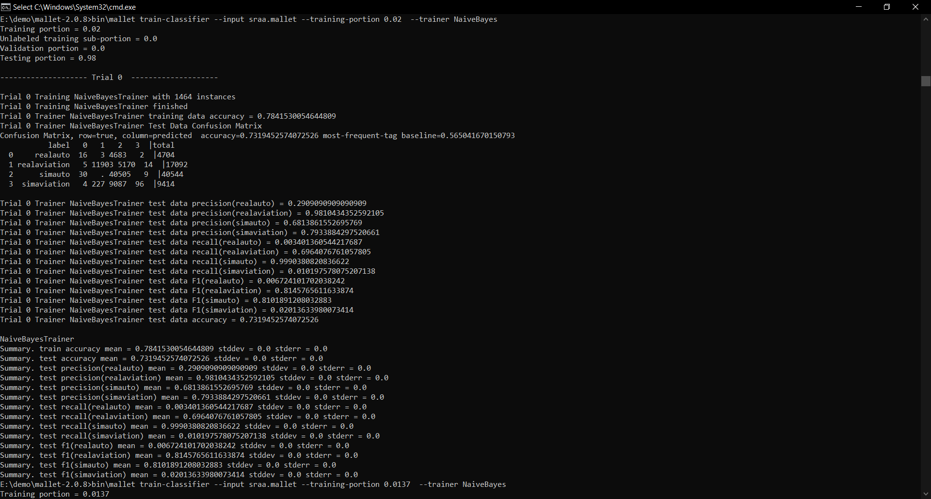

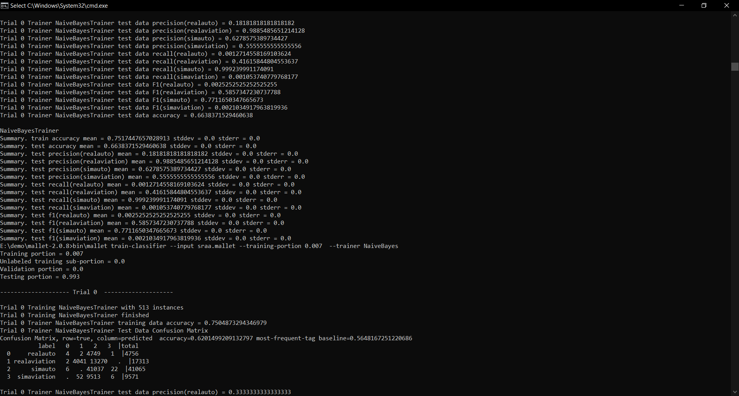

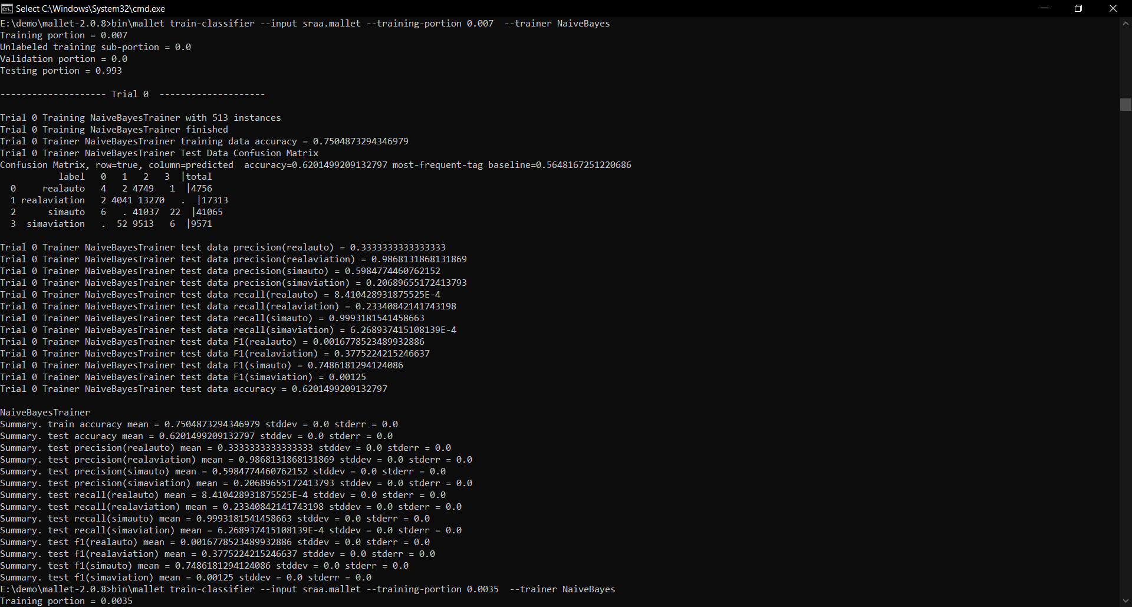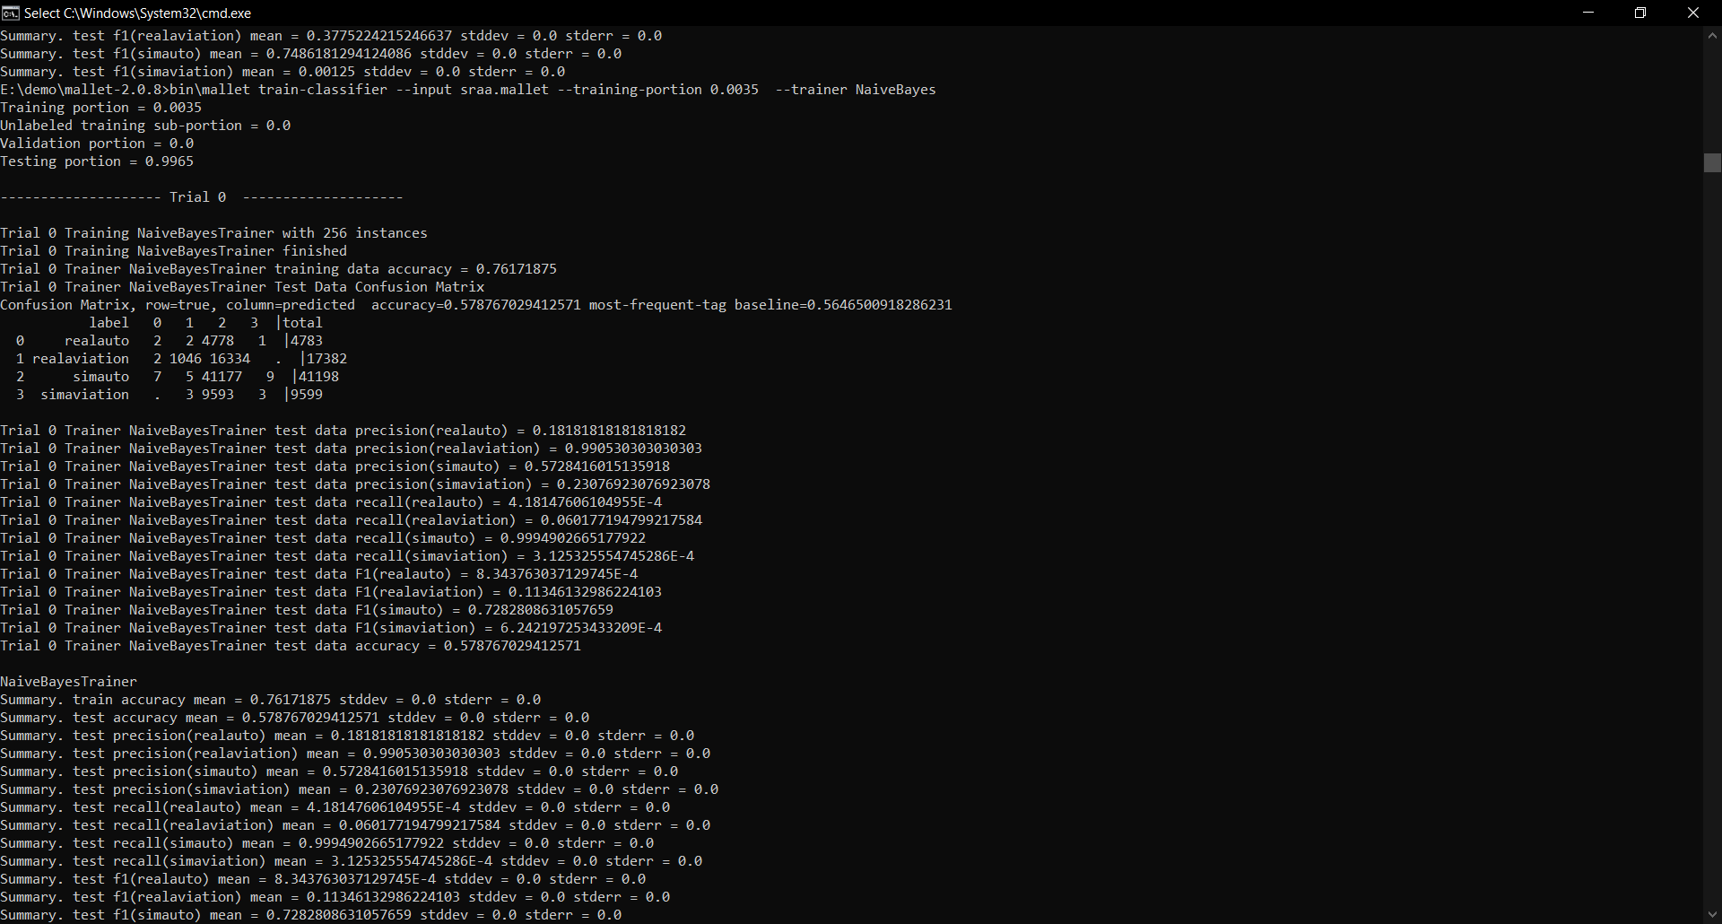

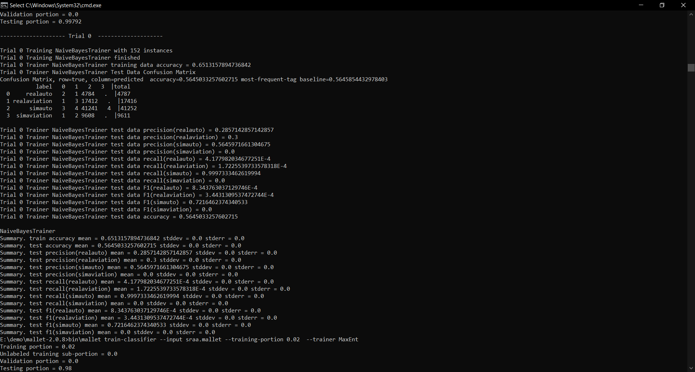

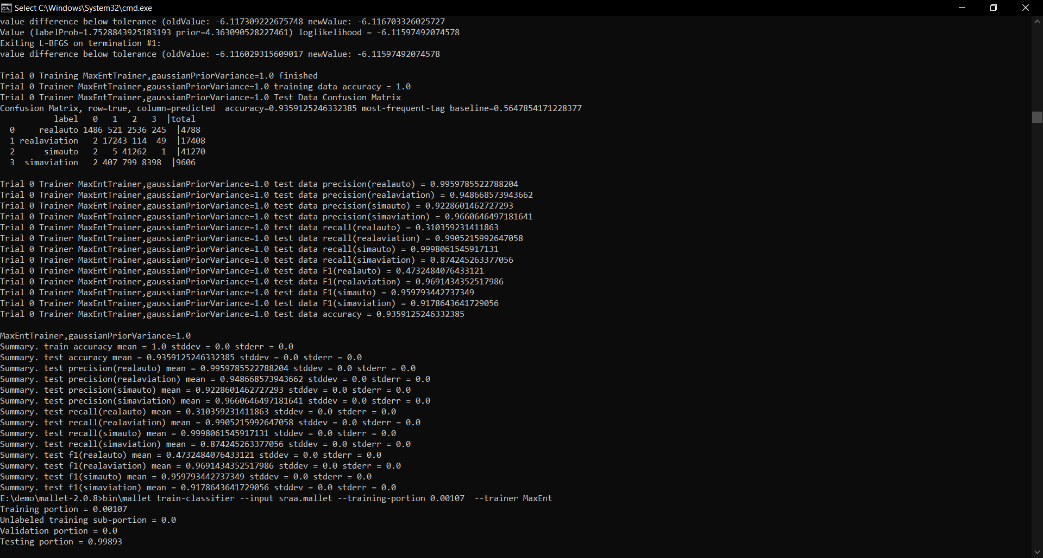

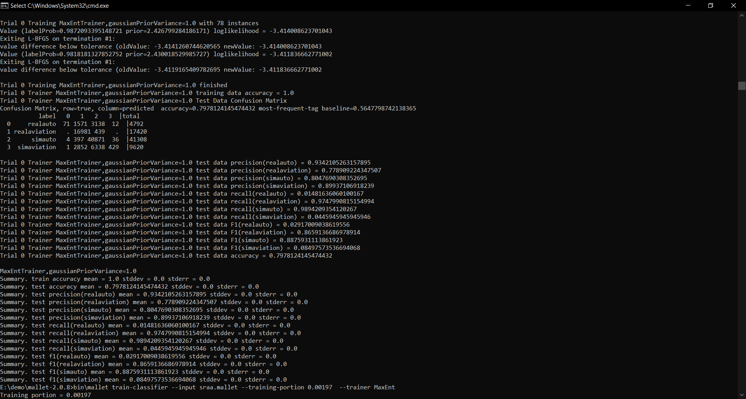

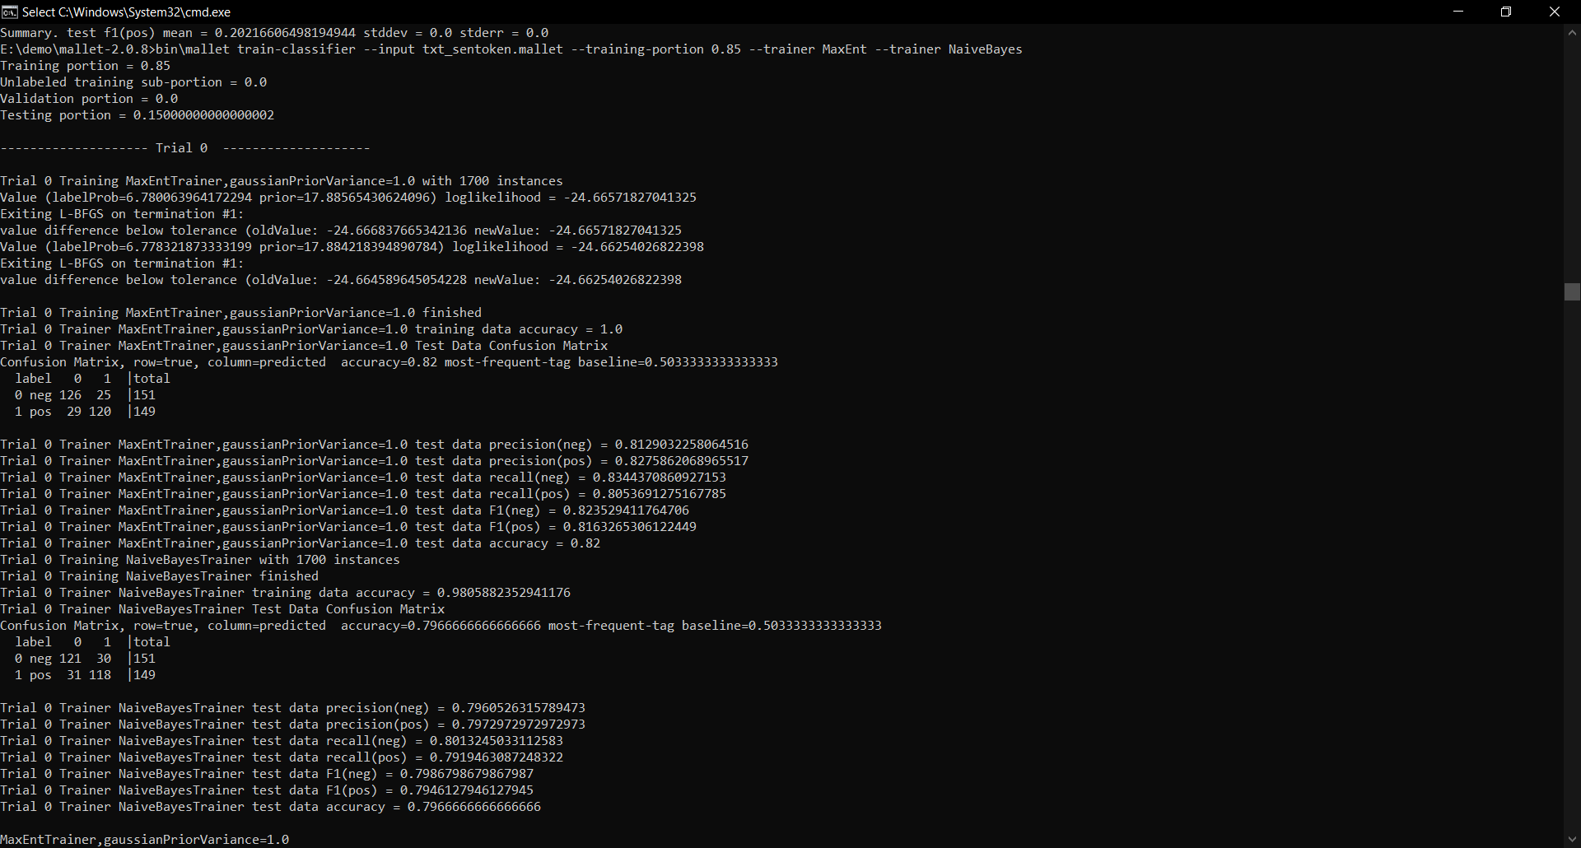

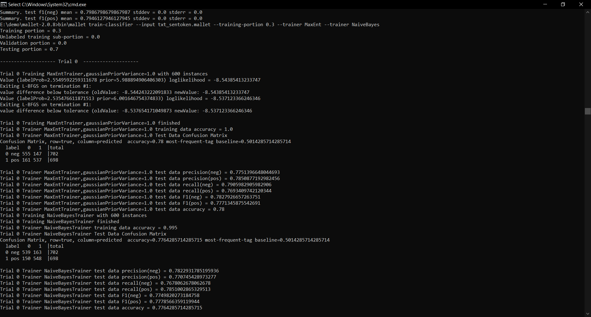

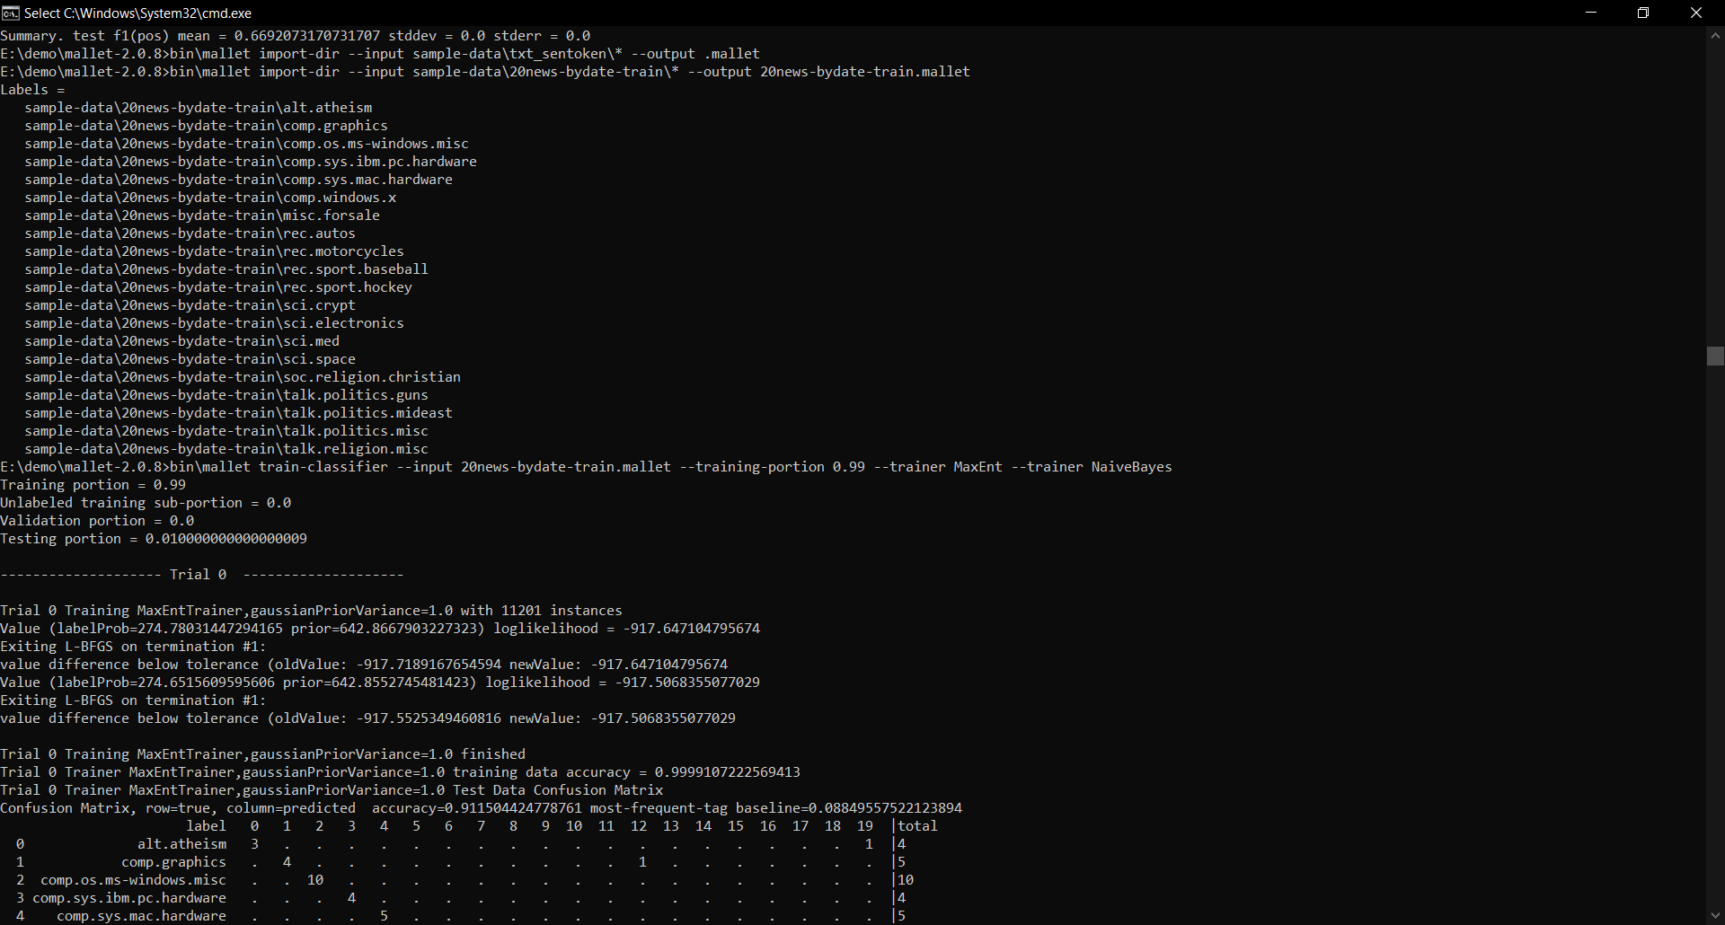

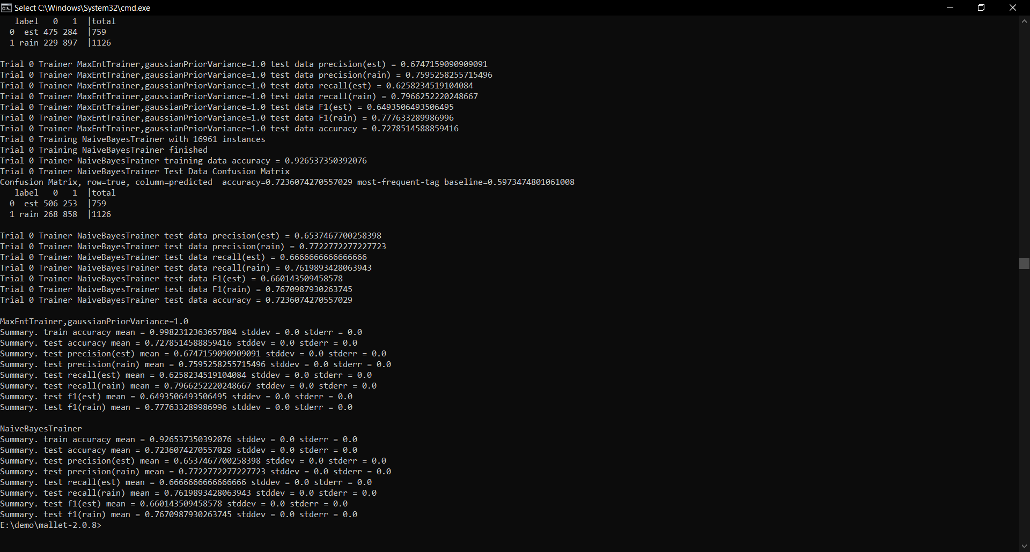

SVM PYTHON CODE FOR NEWSGROUP:

from sklearn.datasets import fetch_20newsgroups

from sklearn.feature_extraction.text import TfidfVectorizer

from sklearn.svm import SVC

from sklearn.pipeline import make_pipeline

from sklearn import metrics

# Load the datasets

train = fetch_20newsgroups(subset='train', shuffle=True, random_state=42)

test = fetch_20newsgroups(subset='test', shuffle=True, random_state=42)

# Create a pipeline that combines a TF-IDF vectorizer with an SVM classifier

model = make_pipeline(TfidfVectorizer(), SVC(kernel='linear'))

# Train the model

model.fit(train.data, train.target)

# Predict the categories for the test data

predicted = model.predict(test.data)

# Calculate the accuracy

accuracy = metrics.accuracy_score(test.target, predicted)

print(f'Accuracy: {accuracy:.2f}')

# Display the classification report

print(metrics.classification_report(test.target, predicted, target_names=test.target_names))

# Optionally, display the confusion matrix

conf_matrix = metrics.confusion_matrix(test.target, predicted)

print(conf_matrix)

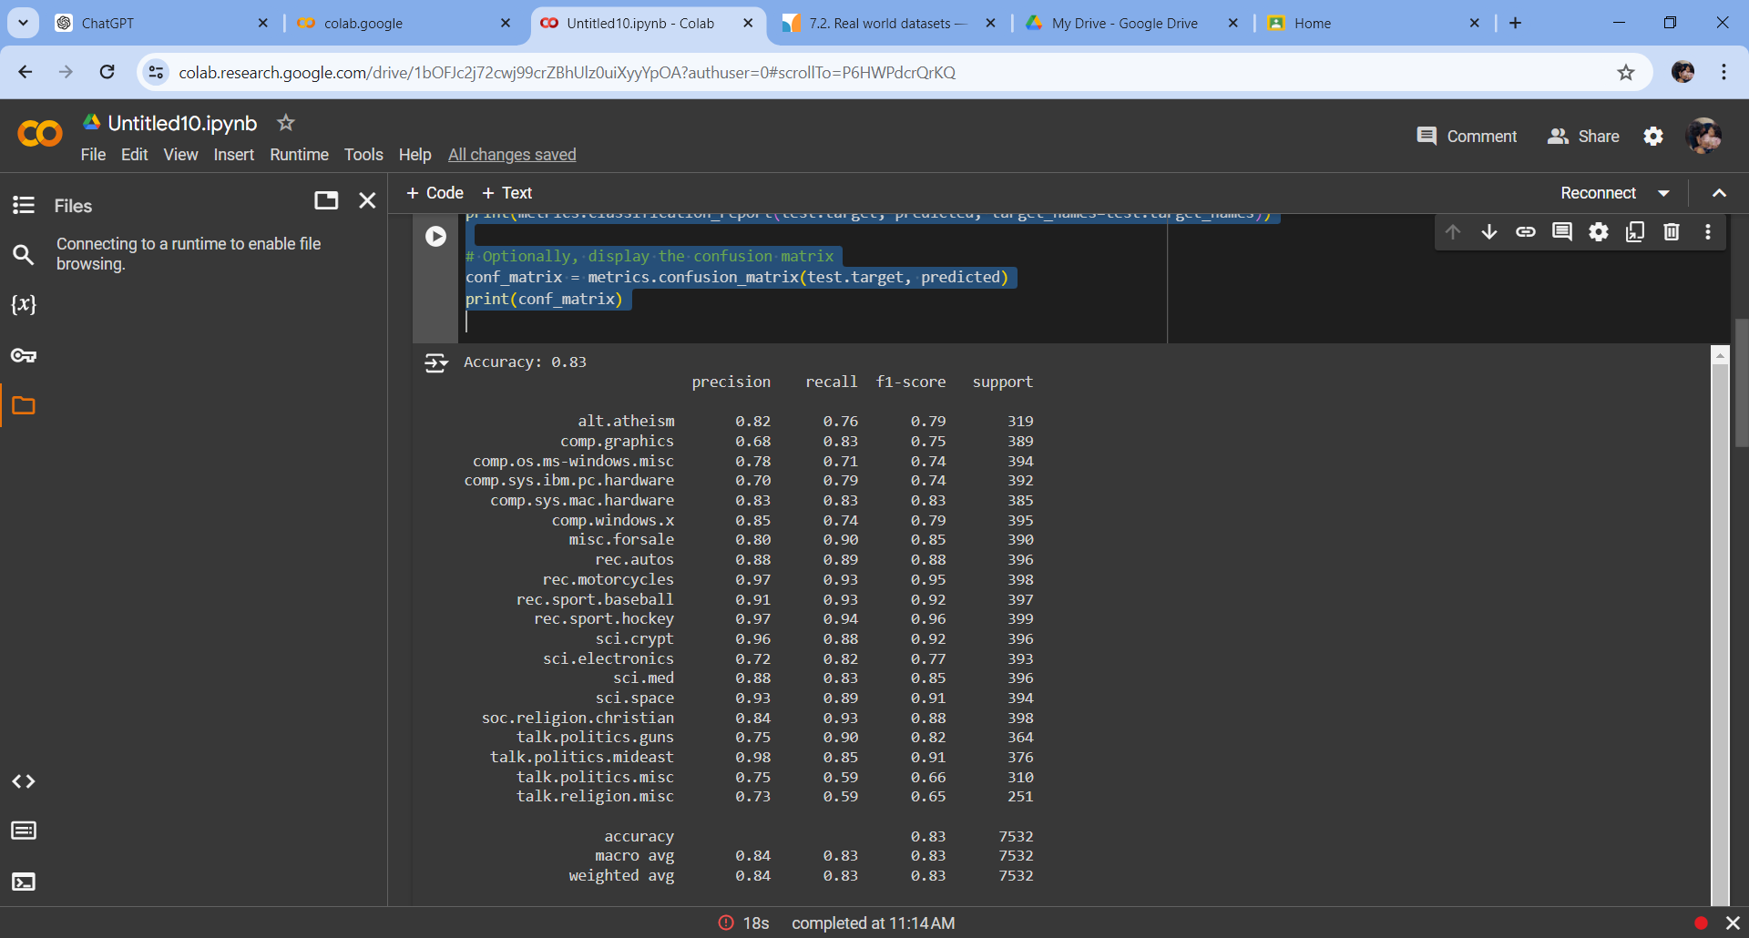

FOR MOVIE REVIEW:

import os

import numpy as np

from sklearn.feature_extraction.text import TfidfVectorizer

from sklearn.svm import SVC

from sklearn.pipeline import make_pipeline

from sklearn import metrics

from sklearn.model_selection import train_test_split

# Function to load data from the folder

def load_data_from_folder(folder_path):

    texts = []

    labels = []

    for label in os.listdir(folder_path):

        label_path = os.path.join(folder_path, label)

        if os.path.isdir(label_path):

            for filename in os.listdir(label_path):

                file_path = os.path.join(label_path, filename)

                with open(file_path, 'r', encoding='utf-8') as file:

                    texts.append(file.read())

                    labels.append(label)

    return texts, labels

# Load the dataset

folder_path = '/content/drive/MyDrive/txt_sentoken'  # Update this path to your dataset folder

texts, labels = load_data_from_folder(folder_path)

# Split the data into training and testing sets

train_data, test_data, train_labels, test_labels = train_test_split(texts, labels, train_size=0.1, random_state=42)

# Create a pipeline that combines a TF-IDF vectorizer with an SVM classifier

model = make_pipeline(TfidfVectorizer(), SVC(kernel='linear'))

# Train the model

model.fit(train_data, train_labels)

# Predict the categories for the test data

predicted = model.predict(test_data)

# Calculate the accuracy

accuracy = metrics.accuracy_score(test_labels, predicted)

print(f'Accuracy: {accuracy:}')

# Display the classification report

print(metrics.classification_report(test_labels, predicted))

# Optionally, display the confusion matrix

conf_matrix = metrics.confusion_matrix(test_labels, predicted)

print(conf_matrix)

